Derrick McFall

Graphical User Interface

12-Nov-17

Chapter 20 #8-12

8. 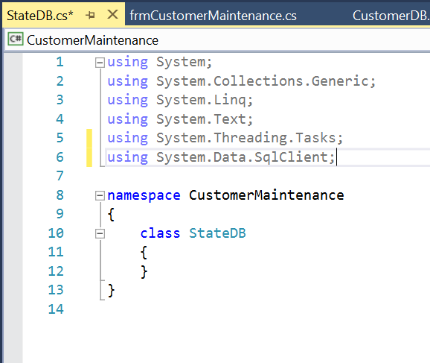

The coded I added was:

using System.Data.SqlClient;

9. 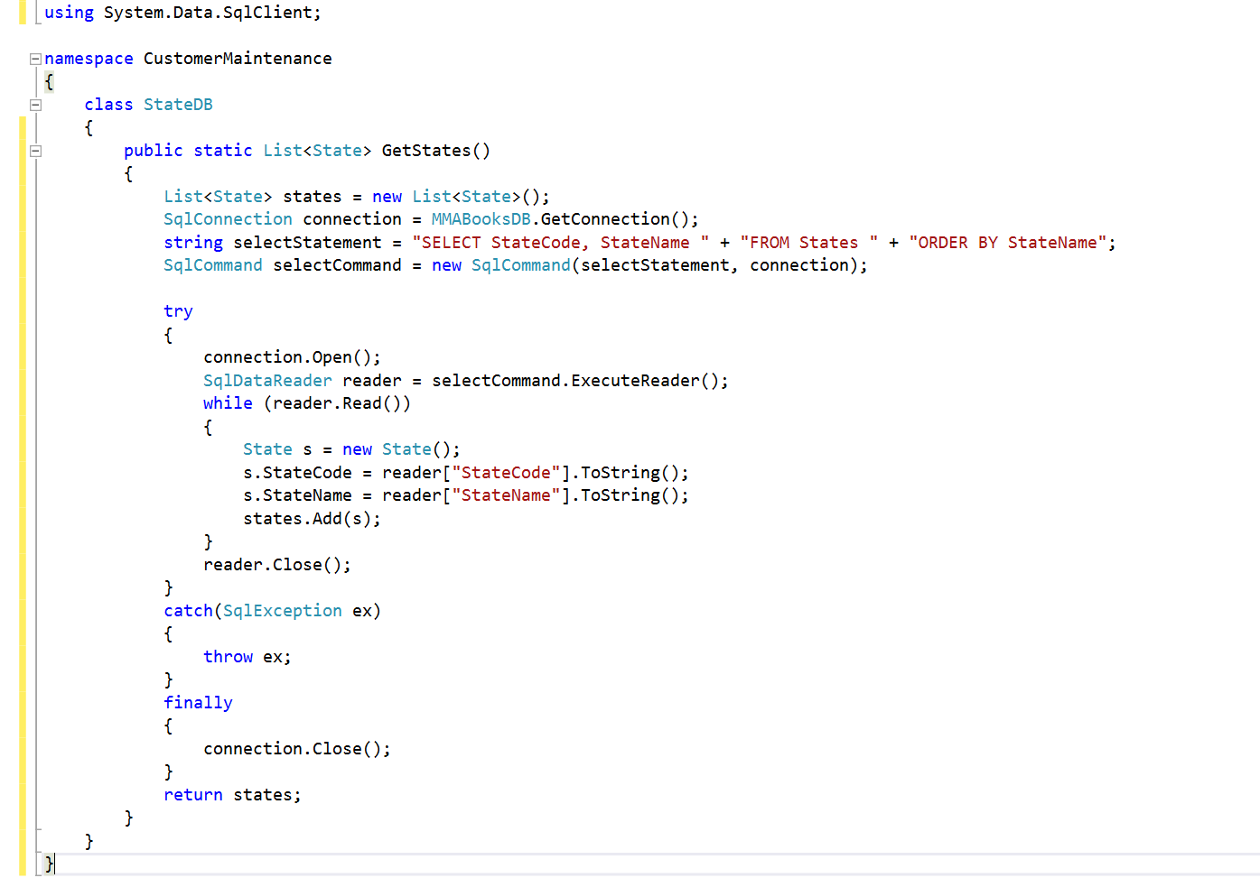

Code added is:

using System.Data.SqlClient;

namespace CustomerMaintenance

{

class StateDB

{

public static List<State> GetStates()

{

List<State> states = new List<State>();

SqlConnection connection = MMABooksDB.GetConnection();

string selectStatement = "SELECT StateCode, StateName " + "FROM States " + "ORDER BY StateName";

SqlCommand selectCommand = new SqlCommand(selectStatement, connection);

try

{

connection.Open();

SqlDataReader reader = selectCommand.ExecuteReader();

while (reader.Read())

{

State s = new State();

s.StateCode = reader["StateCode"].ToString();

s.StateName = reader["StateName"].ToString();

states.Add(s);

}

reader.Close();

}

catch(SqlException ex)

{

throw ex;

}

finally

{

connection.Close();

}

return states;

}

}

}

10. 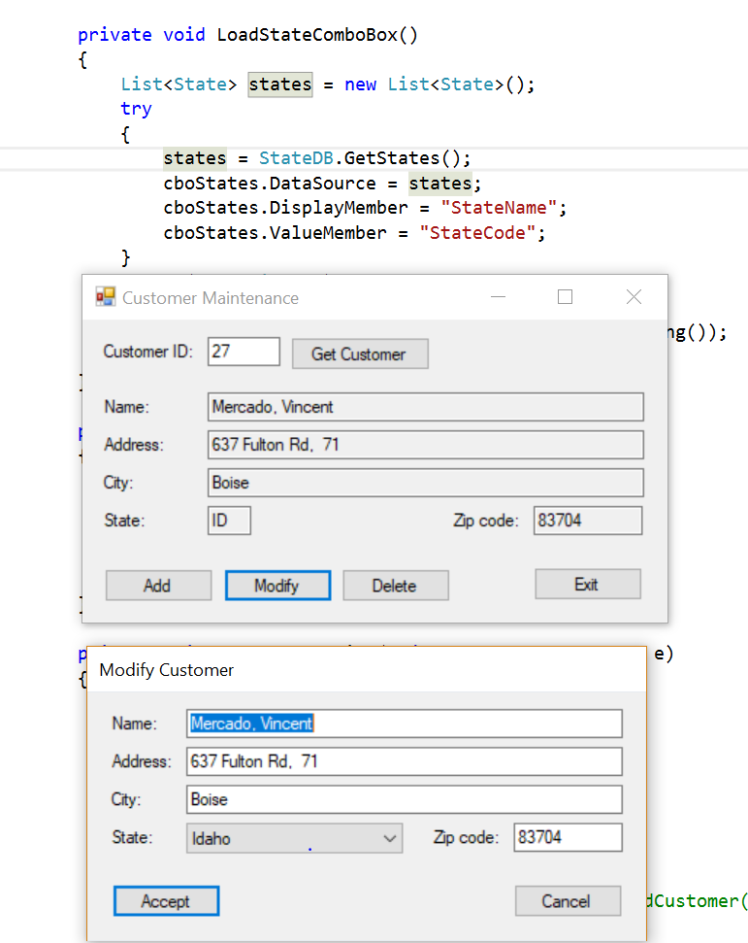

No code added but deleted comment as per the book.

11. 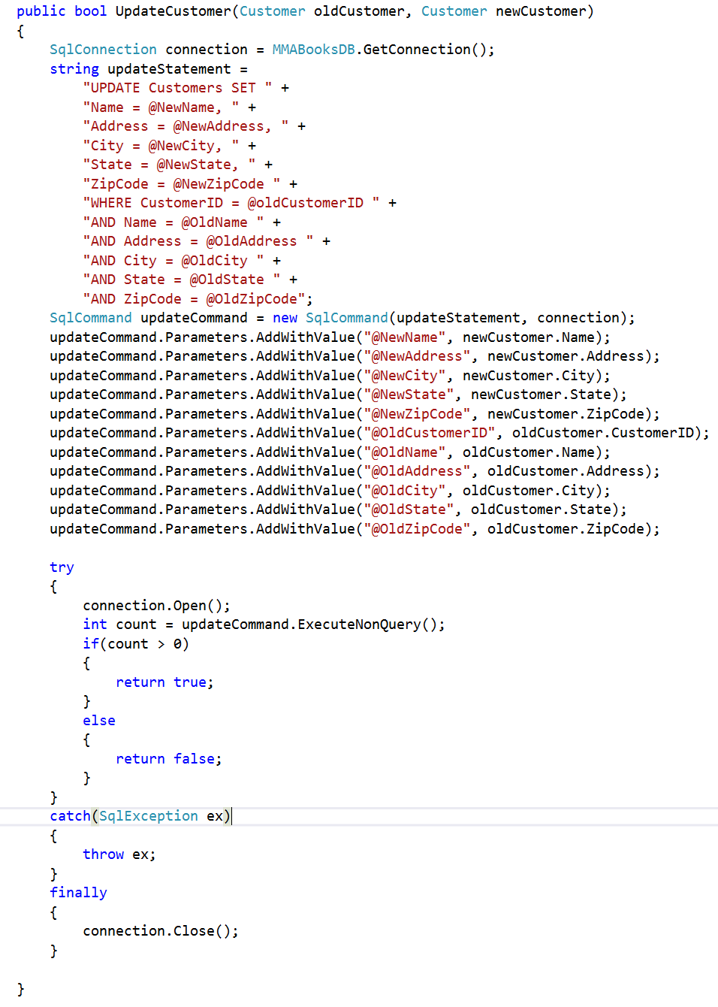

Code added for #11:

public bool UpdateCustomer(Customer oldCustomer, Customer newCustomer)

{

SqlConnection connection = MMABooksDB.GetConnection();

string updateStatement =

"UPDATE Customers SET " +

"Name = @NewName, " +

"Address = @NewAddress, " +

"City = @NewCity, " +

"State = @NewState, " +

"ZipCode = @NewZipCode " +

"WHERE CustomerID = @oldCustomerID " +

"AND Name = @OldName " +

"AND Address = @OldAddress " +

"AND City = @OldCity " +

"AND State = @OldState " +

"AND ZipCode = @OldZipCode";

SqlCommand updateCommand = new SqlCommand(updateStatement, connection);

updateCommand.Parameters.AddWithValue("@NewName", newCustomer.Name);

updateCommand.Parameters.AddWithValue("@NewAddress", newCustomer.Address);

updateCommand.Parameters.AddWithValue("@NewCity", newCustomer.City);

updateCommand.Parameters.AddWithValue("@NewState", newCustomer.State);

updateCommand.Parameters.AddWithValue("@NewZipCode", newCustomer.ZipCode);

updateCommand.Parameters.AddWithValue("@OldCustomerID", oldCustomer.CustomerID);

updateCommand.Parameters.AddWithValue("@OldName", oldCustomer.Name);

updateCommand.Parameters.AddWithValue("@OldAddress", oldCustomer.Address);

updateCommand.Parameters.AddWithValue("@OldCity", oldCustomer.City);

updateCommand.Parameters.AddWithValue("@OldState", oldCustomer.State);

updateCommand.Parameters.AddWithValue("@OldZipCode", oldCustomer.ZipCode);

try

{

connection.Open();

int count = updateCommand.ExecuteNonQuery();

if(count > 0)

{

return true;

}

else

{

return false;

}

}

catch(SqlException ex)

{

throw ex;

}

finally

{

connection.Close();

}

12. 